SEC Form 3
FORM 3 | UNITED STATES SECURITIES AND EXCHANGE COMMISSION
 | Washington, D.C. 20549
 | Washington, D.C. 20549 |  | OMB APPROVAL
 | INITIAL STATEMENT OF BENEFICIAL OWNERSHIP OF SECURITIES
 | INITIAL STATEMENT OF BENEFICIAL OWNERSHIP OF SECURITIES |  | OMB Number: | 3235-0104
 |  |  | Estimated average burden
 | Filed pursuant to Section 16(a) of the Securities Exchange Act of 1934 |  | hours per response: | 0.5
or Section 30(h) of the Investment Company Act of 1940
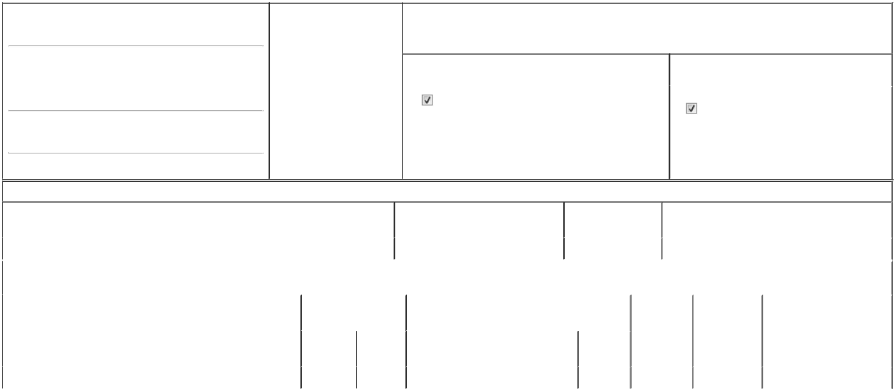

1. Name and Address of Reporting Person*
Leary Susan Michelle

(Last) (First) (Middle)

C/O GROCERY OUTLET HOLDING CORP.

5650 HOLLIS STREET

(Street)
EMERYVILLE CA | 94608

- Date of Event Requiring Statement (Month/Day/Year)
06/09/2026

3. Issuer Name and Ticker or Trading Symbol

Grocery Outlet Holding Corp. [ GO ]

4. Relationship of Reporting Person(s) to Issuer |  | 5. | If Amendment, Date of Original Filed (Month/Day/Year)
(Check all applicable)
Director | 10% Owner
Officer (give title | Other (specify below) | 6. | Individual or Joint/Group Filing (Check Applicable Line)
below) | Other (specify below) |  | Form filed by One Reporting Person
SVP, Accounting |  |  | Form filed by One Reporting Person
SVP, Accounting |  |  | Form filed by More than One Reporting Person

(City) (State) (Zip)

Table I - Non-Derivative Securities Beneficially Owned

1. Title of Security (Instr. 4) | 2. Amount of Securities Beneficially | 3. Ownership Form: | 4. Nature of Indirect Beneficial Ownership (Instr. 5)
 | Owned (Instr. 4) | Direct (D) or Indirect
 |  | (I) (Instr. 5)

 | Common Stock |  |  |  | 46,209⁽¹⁾⁽²⁾ | D
 |  |  | Table II - Derivative Securities Beneficially Owned
 |  | (e.g., puts, calls, warrants, options, convertible securities)
 | 1. Title of Derivative Security (Instr. 4) |  | 2. Date Exercisable and |  | 3. Title and Amount of Securities Underlying |  | 4. | 5. Ownership | 6. Nature of Indirect Beneficial
 |  |  | Expiration Date |  | Derivative Security (Instr. 4) |  | Conversion | Form: Direct | Ownership (Instr. 5)
 |  |  | (Month/Day/Year) |  |  |  | or Exercise | (D) or Indirect
 |  |  |  |  |  |  | Price of | (I) (Instr. 5)
 |  |  |  |  |  | Amount or | Price of | (I) (Instr. 5)
 |  |  |  |  |  | Amount or | Derivative
 |  |  | Date | Expiration | Title | Number of | Security
 |  |  | Exercisable | Date | Title | Shares
 | Performance Stock Unit | (3) |  | (3) | Common Stock | 18,809 | (3) | D
 | Explanation of Responses:

- Includes 34,212 unvested restricted stock units ("RSUs") previously granted on various dates to the reporting person that will entitle the reporting person to receive one share of the Issuer's Common Stock per RSU. The RSUs are subject to the reporting person's completion of service through the following vesting dates: (i) 782 unvested RSUs granted on February 29, 2024 will vest on March 1, 2027; (ii) 3,567 unvested RSUs granted on February 28, 2025 will vest in two remaining equal installments on March 1 of each of 2027 and 2028; (iii) 3,627 unvested RSUs granted on June 12, 2025 will vest in two remaining equal installments on May 20 of each of 2027 and 2028; (iv) 12,540 RSUs granted on March 12, 2026 will vest in three equal installments on March 1 of each of 2027, 2028 and 2029; and (v) 13,696 RSUs granted on March 12, 2026 will vest on March 1, 2027.

- Does not include the following unvested performance-based RSUs ("PSUs") which are eligible to vest upon the achievement of certain performance-based vesting conditions: (i) up to an additional 3,518 unvested PSUs granted on February 29, 2024 at target achievement (or up to an additional 7,036 unvested PSUs at maximum achievement); and (ii) up to an additional 8,025 unvested PSUs granted on February 28, 2025 at target achievement (or up to an additional 16,050 unvested PSUs at maximum achievement).

- Represents a grant of PSUs. Each PSU represents a right to receive one share of the Issuer's common stock upon vesting. The PSUs are earned based on the achievement of specified share price goals for specified time periods during a three-year performance period ending on the last day of the Issuer's fiscal year 2028. The Reporting Person could earn 0-200% of the amount reported depending on the level of performance achieved. The PSUs will vest upon the certification of achievement by the Compensation Committee of the Board of Directors of the Issuer following the end of the performance period, subject to the Reporting Person's continued employment or service with the Issuer as contemplated in the PSU Award Agreement.

Remarks:

Exhibit List: Exhibit 24 - Power of Attorney.

 | /s/ Luke D. Thompson, Luke D. |  |  | 06/16/2026
 | Thompson, Attorney-in-Fact
 | ** Signature of Reporting Person |  |  | Date
Reminder: Report on a separate line for each class of securities beneficially owned directly or indirectly.
* If the form is filed by more than one reporting person, see Instruction 5 (b)(v).
** Intentional misstatements or omissions of facts constitute Federal Criminal Violations See 18 U.S.C. 1001 and 15 U.S.C. 78ff(a).
Note: File three copies of this Form, one of which must be manually signed. If space is insufficient, see Instruction 6 for procedure.
Persons who respond to the collection of information contained in this form are not required to respond unless the form displays a currently valid OMB Number.



