UNITED STATES
SECURITIES AND EXCHANGE COMMISSION
Washington, D.C. 20549

FORM 8-K
CURRENT REPORT
Pursuant to Section 13 or 15(d)
of the Securities Exchange Act of 1934
Date of Report (Date Earliest Event reported):
June 25, 2025

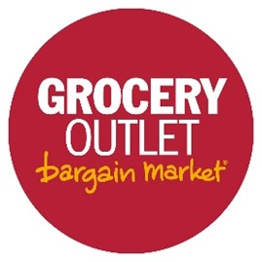
Grocery Outlet Holding Corp.
(Exact name of registrant as specified in its charter)
Delaware |  |  |  |  |  | 001-38950 |  |  |  |  |  | 47-1874201
(State or other jurisdiction of  incorporation) |  |  |  |  |  | (Commission  File Number) |  |  |  |  |  | (I.R.S. Employer  Identification No.)
5650 Hollis Street,  Emeryville, California |  |  |  |  |  |  |  |  |  |  |  | 94608
(Address of principal executive offices) |  |  |  |  |  |  |  |  |  |  |  | (Zip Code)
(510) 845-1999
(Registrant's telephone number, including area code)
___________________________________

Check the appropriate box below if the Form 8-K filing is intended to simultaneously satisfy the filing obligation of the registrant under any of the following provisions:
☐ |  |  | Written communications pursuant to Rule 425 under the Securities Act (17 CFR 230.425)
☐ |  |  | Soliciting material pursuant to Rule 14a-12 under the Exchange Act (17 CFR 240.14a-12)

☐ |  |  | Pre-commencement communications pursuant to Rule 14d-2(b) under the Exchange Act (17 CFR 240.14d-2(b))

☐ |  |  | Pre-commencement communications pursuant to Rule 13e-4(c) under the Exchange Act (17 CFR 240.13e-4(c))

Securities registered pursuant to Section 12(b) of the Act:
Title of each class |  |  | Trading Symbol |  |  | Name of each exchange on which registered
Common stock, par value $0.001 per share |  |  | GO |  |  | Nasdaq Global Select Market

Indicate by check mark whether the registrant is an emerging growth company as defined in Rule 405 of the Securities Act of 1933 (§230.405 of this chapter) or Rule 12b-2 of the Securities Exchange Act of 1934 (§240.12b-2 of this chapter).
Emerging growth company ☐
If an emerging growth company, indicate by check mark if the registrant has elected not to use the extended transition period for complying with any new or revised financial accounting standards provided pursuant to Section 13(a) of the Exchange Act. ☐

Item 5.02 Departure of Directors or Certain Officers; Election of Directors; Appointment of Certain Officers; Compensatory Arrangements of Certain Officers.
On June 25, 2025, the board of directors (the “Board”) of Grocery Outlet Holding Corp., a Delaware corporation (the “Company”), increased the size of the Board from ten to twelve directors, and appointed each of Michael Kobayashi and Lawrence “Chip” Molloy as a Class I director, effective June 26, 2025, to each serve a term expiring at the Company’s 2026 annual meeting of stockholders. The Board also appointed Messrs. Kobayashi and Molloy each to serve as a member of the Audit and Risk Committee of the Board.
On June 25, 2025, Kenneth W. Alterman and Thomas F. Herman informed the Company of their respective decision to retire as Class I directors of the Board and from the Board committees on which they serve, in each case effective as of August 7, 2025. Neither Mr. Alterman’s nor Mr. Herman’s decision to retire was due to any disagreement with the Company’s operations, policies or practices.
The Board approved a reduction in the size of the Board from twelve to ten directors effective upon the retirements of Messrs. Alterman and Herman on August 7, 2025.
The Board has determined that each of Messrs. Kobayashi and Molloy qualifies as an independent director and satisfies all applicable requirements to serve on the Audit and Risk Committee of the Board, including the applicable requirements of The Nasdaq Stock Market LLC and the Securities Exchange Act of 1934, as amended (the "Exchange Act"). The Board has also determined that Mr. Molloy qualifies as an “audit committee financial expert” within the meaning of the regulations of the Securities and Exchange Commission (the “SEC”).
Mr. Kobayashi has extensive executive leadership experience in retail technology, supply chain and store operations, including over 20 years in executive roles with Ross Stores, Inc. (Nasdaq: ROST), a public company discount retailer, where he currently serves as an advisor. During his tenure at Ross Stores, Mr. Kobayashi served as the President and Chief Capability Officer from February 2022 to March 2025; President, Operations and Technology from August 2019 to January 2022; Group Executive Vice President, Supply Chain, Allocation, Merchant Operations and Technology from 2015 to 2019; Executive Vice President, Supply Chain, Inventory Allocation and Chief Information Officer from 2010 to 2014; Group Senior Vice President, Supply Chain and Chief Information Officer from 2008 to 2010; and Senior Vice President and Chief Information Officer from 2004 to 2008. From 1986 to 2004, he served in various roles of increasing responsibility at Accenture plc (NYSE: ACN), including as a Partner from 2000 to 2004. Mr. Kobayashi holds a Bachelor of Science in Managerial Economics from the University of California, Davis.
Mr. Molloy has extensive leadership experience and over 25 years of experience in financial, accounting, financial reporting, grocery, consumer products, high-growth retail, enterprise risk and global matters, including through numerous executive and director roles for various public companies. Mr. Molloy previously served as the Chief Financial Officer of Sprouts Farmers Market, Inc. (Nasdaq: SFM) from September 2021 to December 2023, and prior to that, as Interim Chief Financial Officer from June 2019 to February 2020. He previously served as Chief Financial Officer or in other financial and accounting roles for numerous public and private companies since 1998. Mr. Molloy has 19 years of collective experience serving as a public company board director for six companies, including serving as Chair of the Audit Committee for each board. He currently serves as a board director of Sally Beauty Holdings, Inc. (NYSE: SBH), Pet Valu Holdings Ltd. (TSX: PET.TO), and BRC Inc. (d/b/a Black Rifle Coffee Company) (NYSE: BRCC). Previously, he served as a director for Sprouts Farmers Market, Inc. from 2013-2021, for Torrid Holdings Inc. (NYSE:CURV) from 2018 to 2021, for Party City Holdings Inc. (NYSE:PRTY) from 2014 to 2016 and for Wingstop Inc. (NASDAQ:WING) from 2015 to 2016. Prior to his business career, Mr. Molloy served as a U.S. Navy fighter pilot for 10 years, later retiring from the Naval Reserve with the rank of Commander. He holds Master of Business Administration from the University of Virginia and a Bachelor of Science in Computer Science from the United States Naval Academy.
Messrs. Kobayashi and Molloy will each receive compensation as a non-employee director in accordance with the Company’s non-employee director compensation policy, which was previously filed with the SEC as Exhibit 10.1 to the Company’s Quarterly Report on Form 10-Q for the quarterly period ended June 29, 2024.
Messrs. Kobayashi and Molloy will each be a party to the Company's customary indemnification agreement for the benefit of Board directors and executive officers of the Company, the form of which was previously filed with the SEC as Exhibit 10.31 to the Company’s Registration Statement on Form S-1. There are no arrangements or understandings between either of Messrs. Kobayashi and Molloy and any other person pursuant to which they were selected as directors. Neither Mr. Kobayashi nor Mr. Molloy have family relationships with any director or executive officer of the Company, and there are no transactions in which either of them have a material interest requiring disclosure under Item 404(a) of Regulation S-K.

Item 7.01 Regulation FD Disclosure.
On June 26, 2025, the Company issued a press release announcing Messrs. Kobayashi’s and Molloy’s respective appointments as Class I directors of the Board. A copy of the press release is attached to this report as Exhibit 99.1 and is incorporated herein by reference.
The information in Item 7.01 of this current report on Form 8-K (including Exhibit 99.1 furnished herewith) shall not be deemed "filed" for purposes of Section 18 of the Exchange Act, or otherwise subject to the liabilities of that section, nor shall it be deemed incorporated by reference in any filing under the Securities Act of 1933, as amended, or the Exchange Act, except as expressly set forth by specific reference in such a filing.
Item 9.01 Financial Statements and Exhibits.
(d) Exhibits.
Exhibit No. |  |  |  |  |  | Description
99.1 |  |  |  |  |  | Press release, dated June 26, 2025, entitled “Grocery Outlet Announces Board Refreshment”
104 |  |  |  |  |  | Cover Page Interactive Data File - the cover page interactive data file does not appear in the Interactive Data File because its XBRL tags are embedded within the Inline XBRL document.

Signatures
Pursuant to the requirements of the Securities Exchange Act of 1934, the registrant has duly caused this report to be signed on its behalf by the undersigned hereunto duly authorized.

 |  |  |  |  |  |  |  |  | Grocery Outlet Holding Corp.
Date: |  |  | June 26, 2025 |  |  |  |  |  | By: |  |  | /s/ Luke D. Thompson
 |  |  |  |  |  |  |  |  | Name: |  |  | Luke D. Thompson
 |  |  |  |  |  |  |  |  | Title: |  |  | Executive Vice President, General Counsel and Secretary

Exhibit 99.1

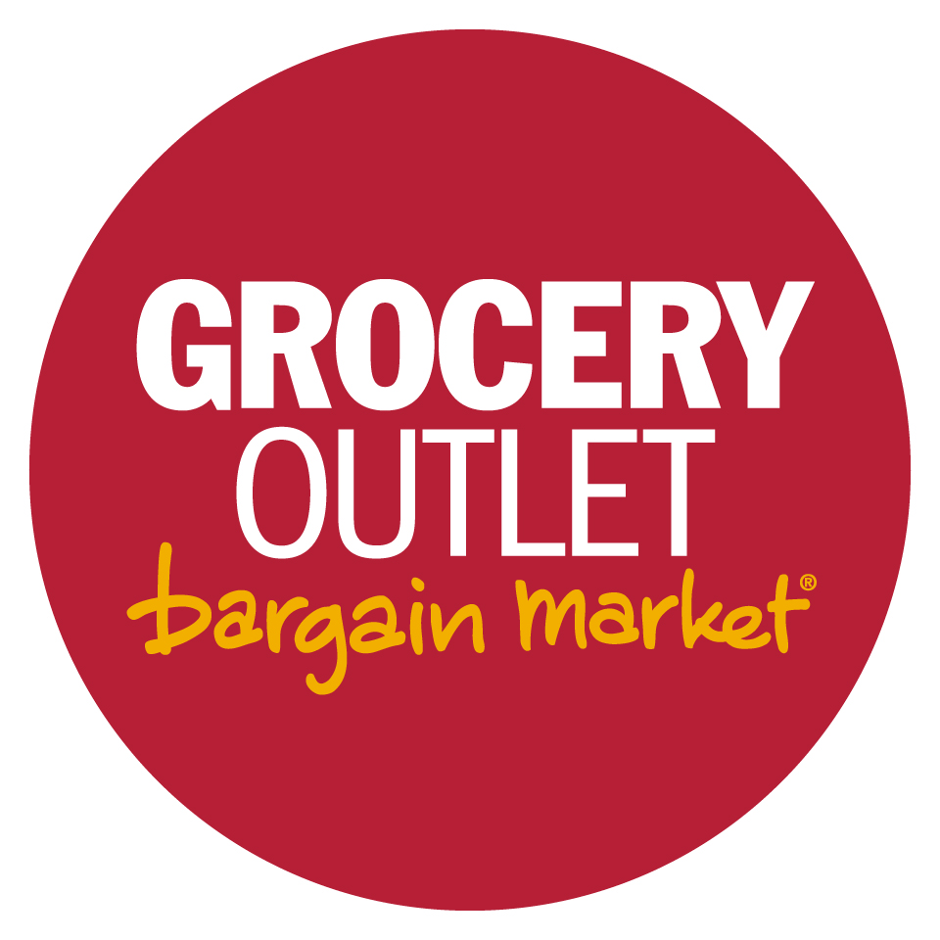
Grocery Outlet Announces Board Refreshment
Adds Two New Independent Directors with Relevant Expertise to Support Next Chapter of Growth
Two Long-serving Directors to Retire in August
Emeryville, CA – June 26, 2025 – Grocery Outlet Holding Corp. (NASDAQ: GO) ("Grocery Outlet," the "Company," "we" or "our") announced the appointments of Michael Kobayashi and Lawrence “Chip” Molloy to its Board of Directors, effective today, as part of the Company’s Board refreshment and leadership transition efforts, which are designed to drive the Company’s next chapter of growth and enhanced profitability. Messrs. Kobayashi and Molloy will both also serve on the Board’s Audit and Risk Committee. Messrs. Kobayashi and Molloy were selected to join the Board following a national search conducted with the assistance of a leading independent search firm. The Company also announced that directors Kenneth Alterman and Thomas Herman have each informed the Board of their plan to retire effective August 7, 2025, after the Company’s next regularly scheduled quarterly Board meeting. With the new director appointments, the Company’s Board has been increased from 10 to 12 directors, and upon the retirement of Messrs. Alterman and Herman, the Board will be reduced to 10 directors, eight of whom are independent.
“The changes to our Board that we are announcing today reflect our commitment to periodic board refreshment and our continued focus on executing our growth plan and enhancing shareholder value,” said Eric Lindberg, Chairman of Grocery Outlet’s Board of Directors. “Mike Kobayashi’s decades of leadership experience in the retail industry, particularly in driving operational excellence and leading large-scale technology transformations, bring valuable perspective as we continue to unlock the full value of our recent systems integration. Chip Molloy’s proven financial leadership experience at highly regarded growth-oriented retailers will complement efforts to sharpen our focus on further driving strong investment returns and greater profitability. I also want to take the opportunity to thank our retiring Board members, Ken Alterman and Tom Herman, for their many years of extraordinary service and dedication to our Board and Grocery Outlet. Their contributions have shaped Grocery Outlet into the resonant brand that it is today and set the business on a path to deliver sustainable, profitable growth in the years to come.”
Michael Kobayashi
Mike Kobayashi brings over 20 years of executive leadership in retail technology, supply chain, and store operations, most notably with Ross Stores, Inc., a public company discount retailer. He currently serves as an advisor to Ross Stores, following key leadership roles including President and Chief Capability Officer, President of Operations and Technology, and Group Executive Vice President of Supply Chain, Allocation, Merchant Operations, and Technology. In these roles, Mr. Kobayashi led significant growth initiatives while also strengthening the company’s supply chain infrastructure, information systems, and data capabilities. He began his career at Accenture plc, a global professional services company, where he was a Partner from 2000 to 2004. Mr. Kobayashi holds a Bachelor of Science in Managerial Economics from the University of California, Davis.
Lawrence “Chip” Molloy
Lawrence “Chip” Molloy brings significant financial and retail leadership expertise, most recently as the Chief Financial Officer of Sprouts Farmers Market, Inc. He previously served as Interim Chief Executive Officer at Torrid Holdings Inc., as Chief Financial Officer of Under Armour, Inc., and as Chief Financial Officer of PetSmart LLC, where he was named Institutional Investor’s CFO of the Year for Specialty Retail in 2011. Mr. Molloy also has substantial board leadership experience, having served on six public company boards since

1

2013 and as Chair of the Audit Committee for each board. Mr. Molloy currently serves on the boards of Sally Beauty Holdings, Inc., Pet Valu Holdings Ltd., and BRC Inc. (Black Rifle Coffee Company). He previously served on the board of Sprouts Farmers Market, Inc. for nearly ten years and also served on the boards of Party City Holdings Inc. and Wingstop Inc. Prior to his business career, Mr. Molloy served as a U.S. Navy fighter pilot for 10 years, retiring from the Naval Reserve with the rank of Commander. He holds a Master of Business Administration from the University of Virginia and a Bachelor of Science in Computer Science from the United States Naval Academy.
About Grocery Outlet
Based in Emeryville, California, Grocery Outlet is a high-growth, extreme value retailer of quality, name-brand consumables and fresh products sold primarily through a network of independently operated stores. Grocery Outlet and its subsidiaries have more than 540 stores in California, Washington, Oregon, Pennsylvania, Tennessee, Idaho, Maryland, Nevada, North Carolina, New Jersey, Ohio, Georgia, Alabama, Delaware, Kentucky and Virginia.
Forward-Looking Statements
This news release includes forward-looking statements within the meaning of the Private Securities Litigation Reform Act of 1995. All statements contained in this release other than statements of historical fact, including the expected leadership and strategic fit of the Company’s newly appointed members of its Board of Directors and achievement of greater growth or profitability, may constitute forward-looking statements. Words such as “anticipate,” “believe,” “estimate,” “expect,” “intend,” “may,” “outlook,” “plan,” “project,” “seek,” “will,” and similar expressions, are intended to identify such forward-looking statements. These forward-looking statements are subject to a number of risks, uncertainties and assumptions that may cause actual results to differ materially from those expressed or implied by any forward-looking statements, including: the availability and supply of opportunistic products and other trending products at attractive pricing; our ability to grow comparable store sales; risks related to new store growth and remodeled stores; inflation and other supply pricing impacts; the success of our brand and product marketing; failure to maintain our supply and distribution networks; risks to cash flows and liquidity; evolving retail competition, including online; catastrophic events and other factors discussed under “Risk Factors” in the Company’s most recent annual report on Form 10-K and in other subsequent reports the Company files with the United States Securities and Exchange Commission (the “SEC”). The Company’s periodic filings are accessible on the SEC’s website at www.sec.gov.
Moreover, the Company operates in a very competitive and rapidly changing environment, and new risks emerge from time to time. Although the Company believes that the expectations reflected in the forward-looking statements are reasonable, and our expectations based on third-party information and projections are from sources that management believes to be reputable, the Company cannot guarantee that future results, levels of activity, performance or achievements. These forward-looking statements are made as of the date of this release or as of the date specified herein and the Company has based these forward-looking statements on current expectations and projections about future events and trends. Except as required by law, the Company does not undertake any duty to update any of these forward-looking statements after the date of this news release or to conform these statements to actual results or revised expectations.

2

INVESTOR RELATIONS CONTACTS:
Grocery Outlet Investor Relations
(510) 244-3703
Investor.Relations@groceryoutlet.com
Ron Clark
(646) 776-0886
ron@ellipsista.com
MEDIA CONTACT:
Layla Kasha
(510) 379-2176
lkasha@cfgo.com

3

