SEC Form 3
FORM 3 | UNITED STATES SECURITIES AND EXCHANGE COMMISSION
 | Washington, D.C. 20549
 | Washington, D.C. 20549 |  | OMB APPROVAL
 | INITIAL STATEMENT OF BENEFICIAL OWNERSHIP OF SECURITIES
 | INITIAL STATEMENT OF BENEFICIAL OWNERSHIP OF SECURITIES |  | OMB Number: | 3235-0104
 |  |  | Estimated average burden
 | Filed pursuant to Section 16(a) of the Securities Exchange Act of 1934 |  | hours per response: | 0.5
or Section 30(h) of the Investment Company Act of 1940
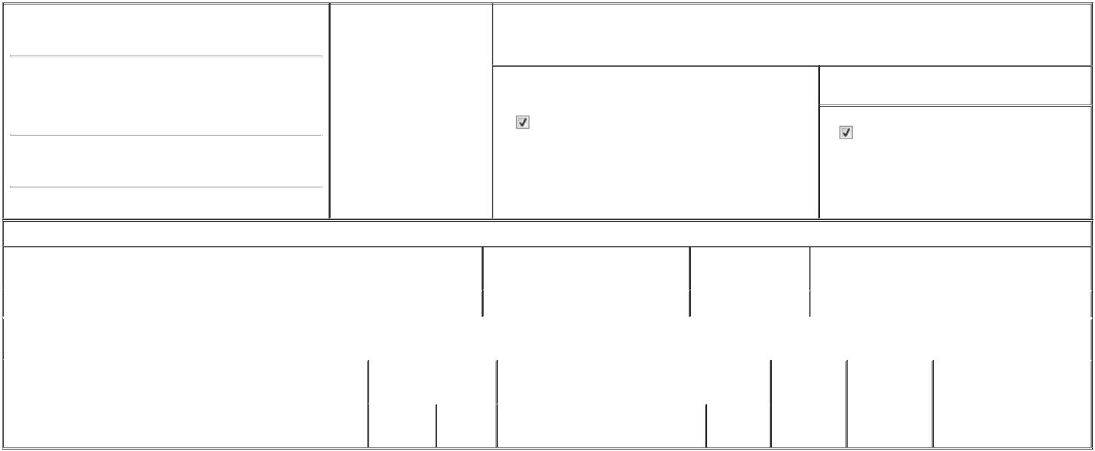

1. Name and Address of Reporting Person*
Miller Paul Blaine

- Date of Event Requiring Statement (Month/Day/Year)
06/09/2026

3. Issuer Name and Ticker or Trading Symbol

Grocery Outlet Holding Corp. [ GO ]

(Last) (First) (Middle)

C/O GROCERY OUTLET HOLDING CORP.

5650 HOLLIS STREET

(Street)
EMERYVILLE CA | 94608

- Relationship of Reporting Person(s) to Issuer (Check all applicable)
Director | 10% Owner
Officer (give title | Other (specify below)
below) | Other (specify below)

See Remarks

- If Amendment, Date of Original Filed (Month/Day/Year)

- Individual or Joint/Group Filing (Check Applicable Line)

Form filed by One Reporting Person

Form filed by More than One Reporting Person

(City) (State) (Zip)

Table I - Non-Derivative Securities Beneficially Owned

1. Title of Security (Instr. 4) | 2. Amount of Securities Beneficially | 3. Ownership Form: | 4. Nature of Indirect Beneficial Ownership (Instr. 5)
 | Owned (Instr. 4) | Direct (D) or Indirect
 |  | (I) (Instr. 5)

 | Common Stock |  |  |  | 21,740⁽¹⁾ | D
 |  |  | Table II - Derivative Securities Beneficially Owned
 |  | (e.g., puts, calls, warrants, options, convertible securities)
 | 1. Title of Derivative Security (Instr. 4) |  | 2. Date Exercisable and |  | 3. Title and Amount of Securities Underlying |  | 4. | 5. Ownership | 6. Nature of Indirect Beneficial
 |  |  | Expiration Date |  | Derivative Security (Instr. 4) |  | Conversion | Form: Direct | Ownership (Instr. 5)
 |  |  | (Month/Day/Year) |  |  |  | or Exercise | (D) or Indirect
 |  |  |  |  |  |  | Price of | (I) (Instr. 5)
 |  |  |  |  |  | Amount or | Price of | (I) (Instr. 5)
 |  |  |  |  |  | Amount or | Derivative
 |  |  | Date | Expiration | Title | Number of | Security
 |  |  | Exercisable | Date | Title | Shares

Explanation of Responses:

1. Represents 21,740 restricted stock units ("RSUs") granted on March 12, 2026 to the reporting person that will entitle the reporting person to receive one share of the Issuer's Common Stock per RSU. The RSUs will vest on March 1, 2027.

Remarks:

(i) The reporting person's title is EVP, Chief Purchasing & Merchandising Officer. (ii) Exhibit List: Exhibit 24 - Power of Attorney.

/s/ Luke D. Thompson, Luke D.

Thompson, Attorney-in-Fact

** Signature of Reporting Person

Reminder: Report on a separate line for each class of securities beneficially owned directly or indirectly.

* If the form is filed by more than one reporting person, see Instruction 5 (b)(v).

- Intentional misstatements or omissions of facts constitute Federal Criminal Violations See 18 U.S.C. 1001 and 15 U.S.C. 78ff(a). Note: File three copies of this Form, one of which must be manually signed. If space is insufficient, see Instruction 6 for procedure.
Persons who respond to the collection of information contained in this form are not required to respond unless the form displays a currently valid OMB Number.

06/16/2026

Date



